

**Final Project Report**

**San Francisco Police Department Incidents Report Analysis**

**Course – Data Management and Big Data (ALY6110)**

**Section 1**

**CRN – 80442**

**Project done by,**

**Group Gamma**

**Group Members: Bhanoji Reddy Meka (Meka.b@northeastern.edu)**

**Shivani Shetkar (Shetkar.s@northeastern.edu)**

**Introduction**

We used Databricks Community edition for the analysis of San Francisco crimes from 2003 – 2018.We used Python and SQL languages to interact for solutions to our Questions and for exploratory analysis.

After Signing in the Databricks Community edition, we need to create a Cluster and import the dataset Police department incident reports by creating a table. To create a table, we need to open the option Data in the side bar and click on Create table and choose option Upload File to browse and import dataset file on device and then open the notebook to copy the dataset location to import dataset.

If the default language selected is Python, to run a SQL code in block we need Write ‘%SQL’ in the first line of the script.

**Default Interface of Databrick Community Edition**

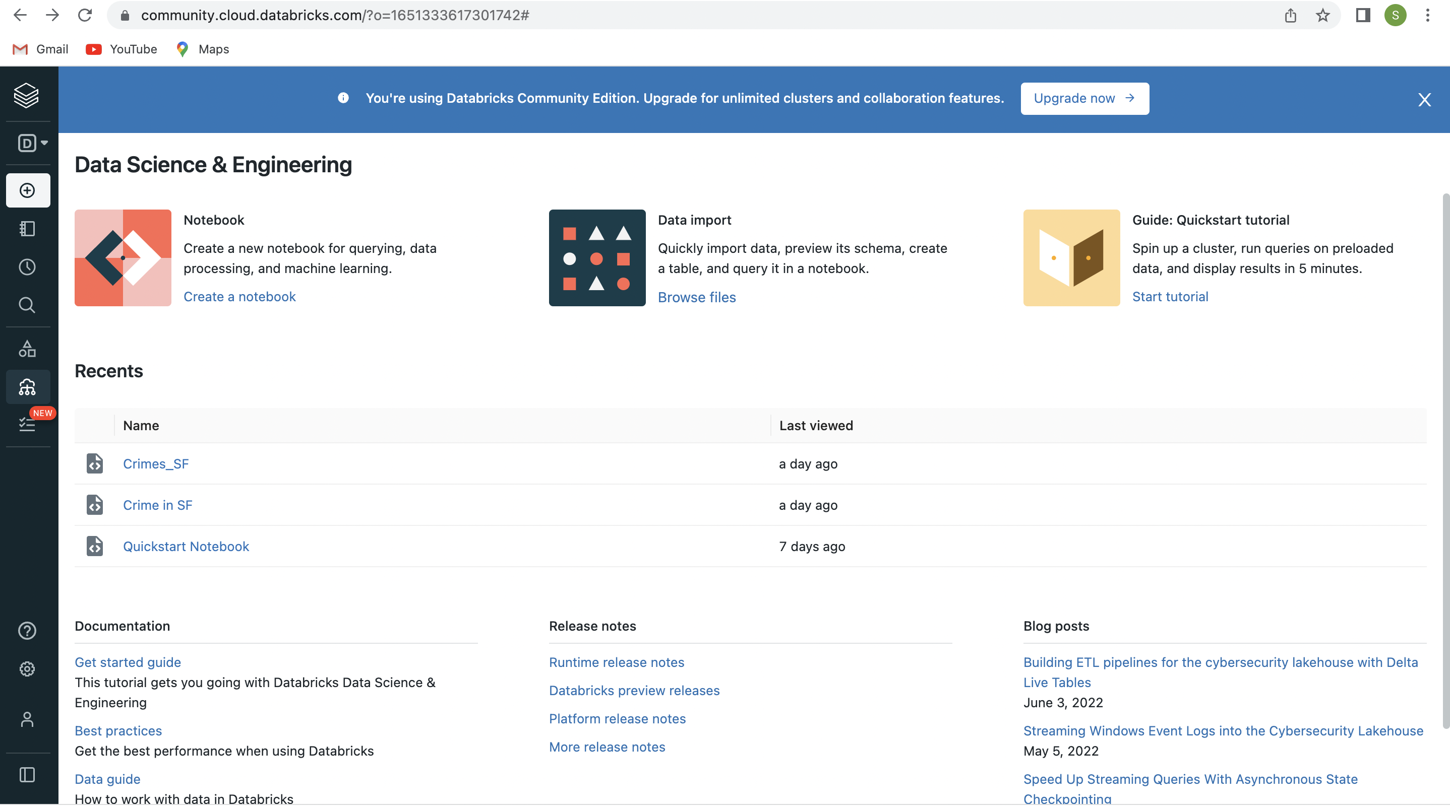

**Sequence in which the cluster and table is created in Notebook**

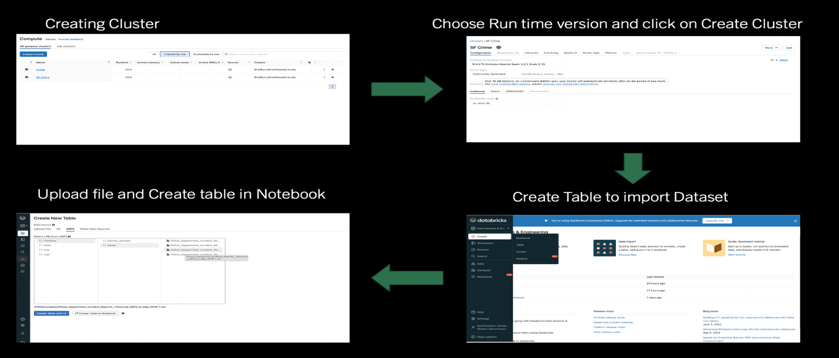

**Dataset –** This dataset is exported from official San Francisco Government organization website (URL provided in Reference). The San Francisco Police department incident report csv file has dimension of **35*1000000** where there 35 columns with 1000000 records.

The attributes are Pdid (Police department ID), Incident Num, Incident Code, Category, descript (Description of Crime), Day of Week, Date, Time, Pd District, Resolution, Address, Latitude, Longitude, Location SF Find Neighborhoods 2 2, Current Police Districts 2 2, Analysis Neighborhood 2 2, Delete – Fire Prevention District 2 2, Delete Police Districts 2 2, Delete – Zip Codes 2 2, Delete Neighborhood 2 2, Delete – 2017 Fix it Zones 2 2.

Other Attributes contain records of Zones/Areas by dates/Boundaries.

Civic Center Harm Reduction Project Boundary 2 2, Fix it Zones as of 2017-11-06 2 2, Delete – HSOC Zones 2 2, Fix it Zones as of 2018-02-07 2 2, CBD, BID and GBD Boundaries as 2017, Areas of Vulnerability, Central Market/Tenderloin Boundary, Central Market/Tenderloin Boundary Polygon – Updated, HSOC Zones as of 2018 – 06- 05, Owed Public Spaces and Neighborhood 2.

**Problem Domain**

* What is the Total number of Incidents/Crimes per every Incident Category?
* How many Districts are there and What is the Total count of all incidents in every district?
* What is the Total Crime Count of latest 5 years of data (2014-2018)?
* What is the Total number of incidents in every district from 2004 to 2018?
* Find out Crimes per every hour of day from Districts with Top 5 Incident Count.
* What are the top 5 types of crimes occurring in each District and How much is the rate of crime percentage for each type of Crime?

**Attributes used to find Solutions** PdID, Incident Number, Incident Code, Category, Description, Day Of Week, Date, Time, PdDistrict, address, X, Y and Location

**Tools Used-** Data Bricks Community Edition, In this project we used Python and SQL code to perform operations.

**Analysis**

To begin with our analysis, Initially We imported packages (as shown in the index) and imported the dataset that we downloaded from the SF Government site as shown in the image below. Sc.textfile ( ) function is used to read the dataset by providing the location of dataset and is stored in the object Incedent_data_text. For the dataset not to be stored only in string type we used df.map () and stored the data in Incident_df (data frame).

We can observe from the Output that all 32 attributes are imported and the top 3 in the table are displayed using the embedded function df.take().

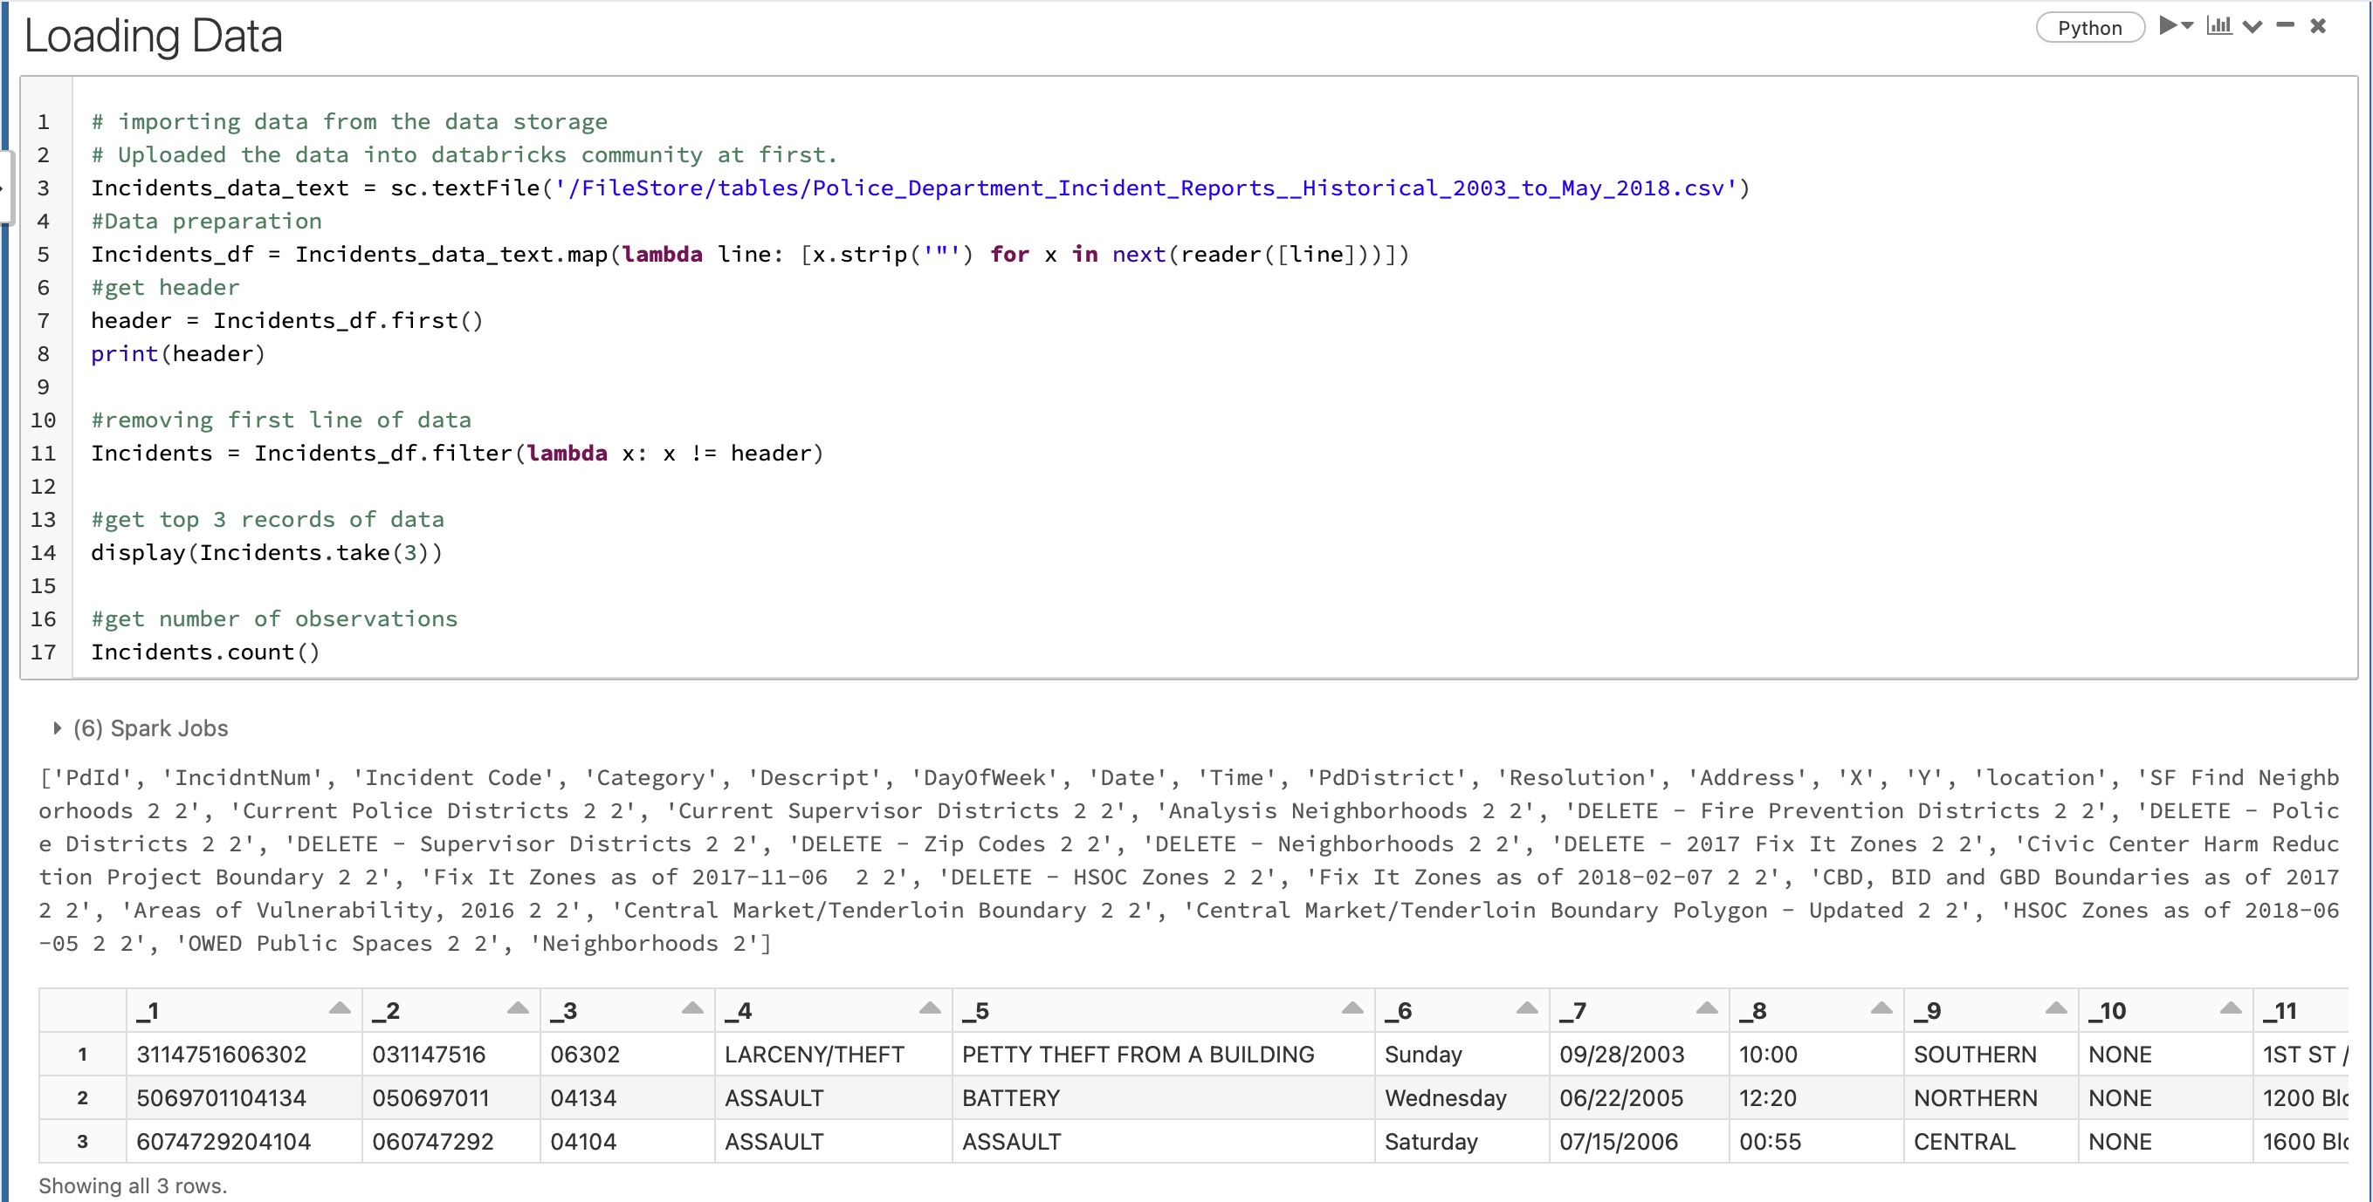

To understand the attributes better, we created another data frame using the attributes we need from the parent data frame using Incidents.toDF() function and modified the attribute name, example- Incident Num to Incident Number, Descript to Description etc.

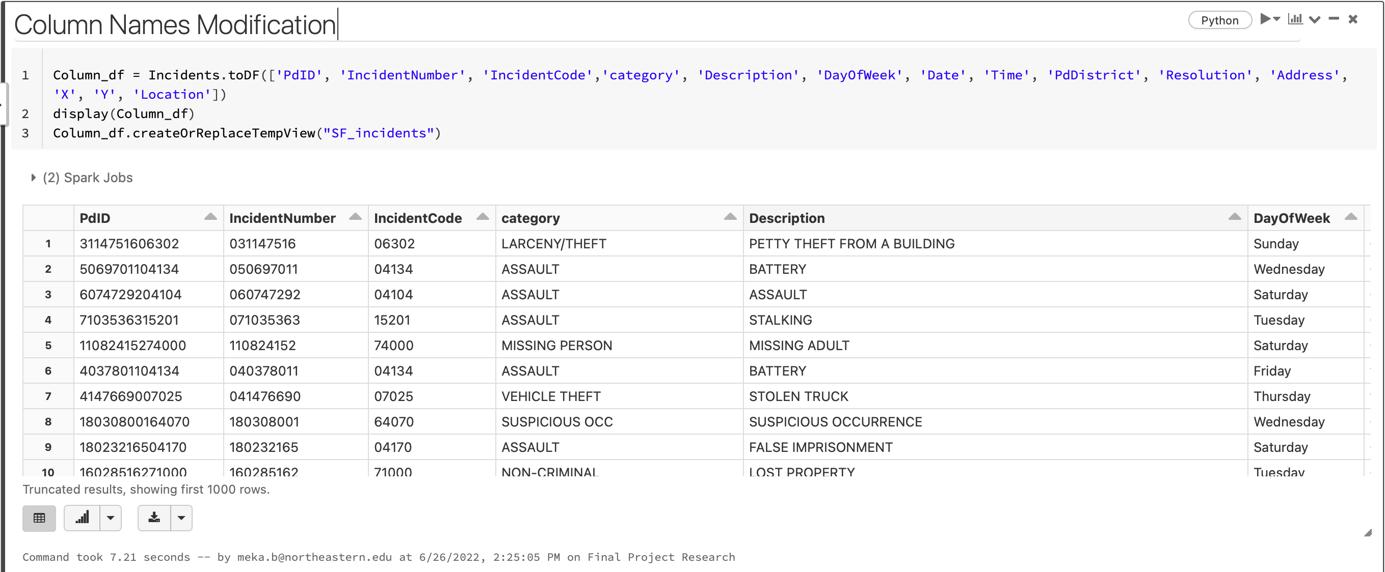

**Total number of Incidents/Crimes per every Incident Category**

The image below is a table showing the count of each category of crime and there are **37 categories of crime in the dataset**. We can tell that the **count in the table is not in increasing order** but in decreasing as you can observe in the SQL query that it is **Group by (‘Category’) and condition in Order by is ascending = ‘false’**.

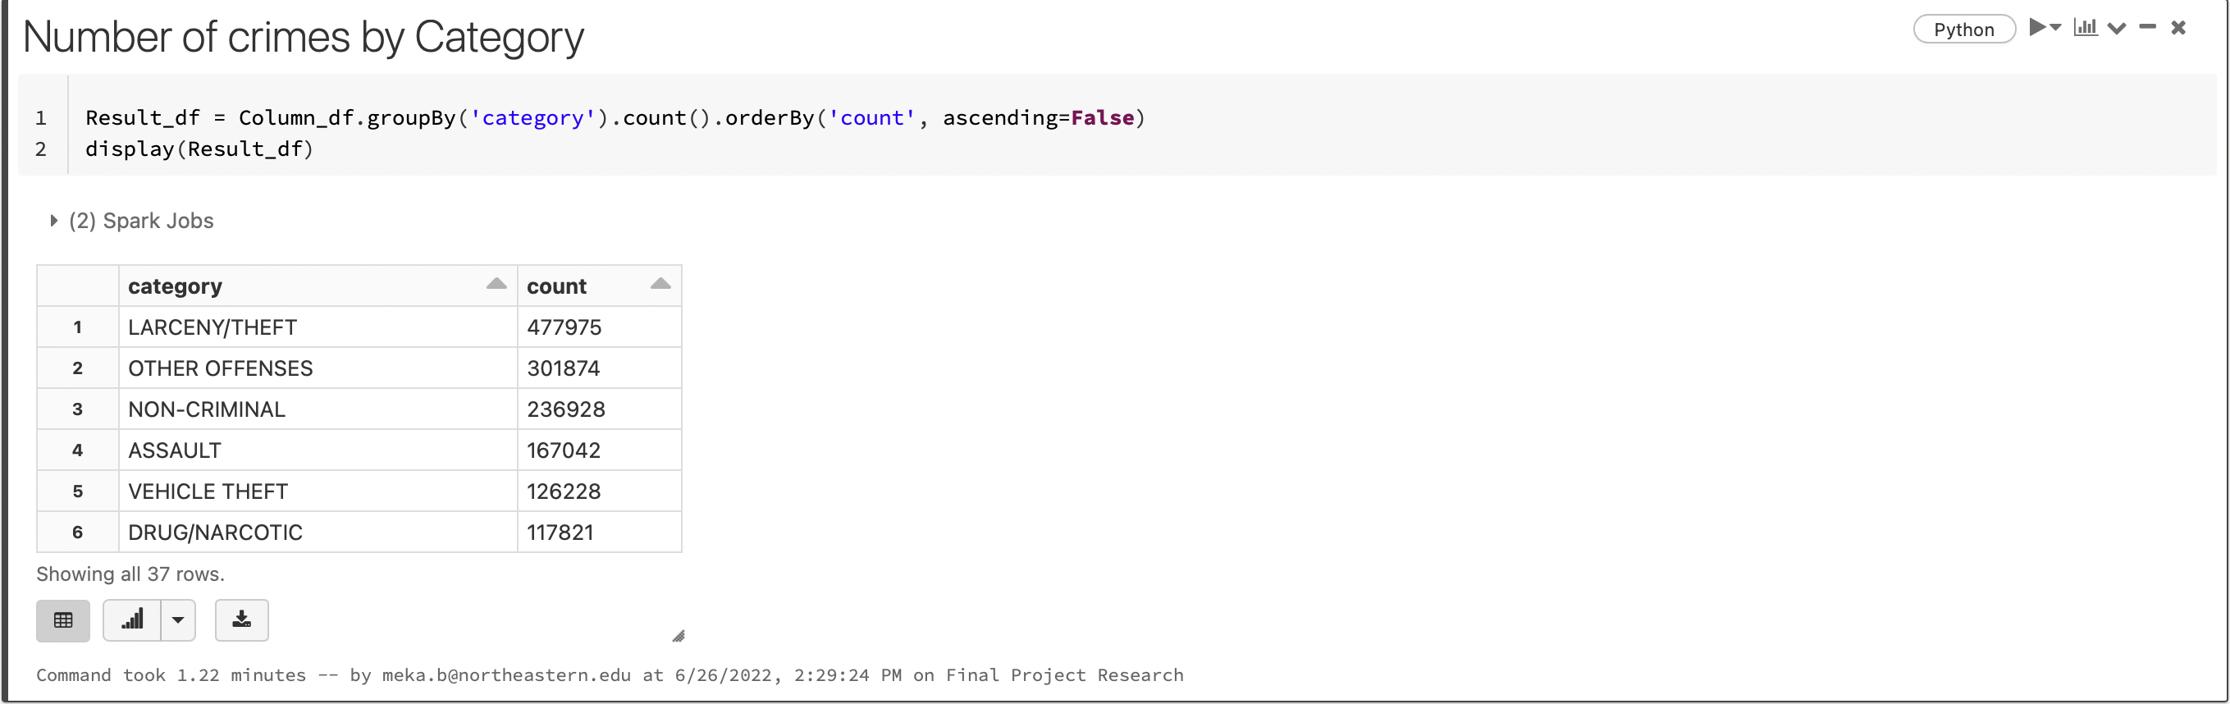

**Visualization of Top 10 Categories of types of incidents** using Display () function as Larceny/theft with count 477975, Other Offenses category with count 301874, Non-Criminal with count 236928, Assault cases are 167042, Vehicle theft cases are 126228 Drug/Narcotic are 117821, Vandalism approximately 115k, Burglary 90k and Suspicious OCC 80k .

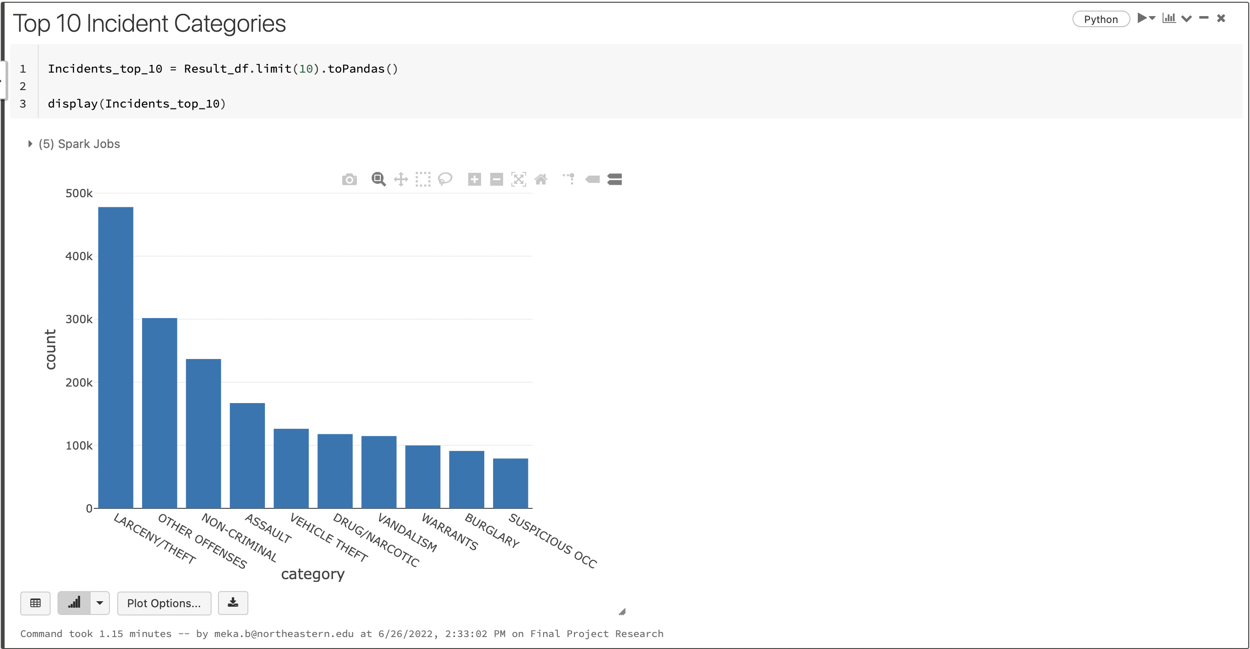

**Total count of all incidents in every district**

Query to **find Incident count Grouped by district**, there are 10 Districts and top 6 districts are southern district with 390692 cases, Mission with 288985, Northern with 266435 cases, Central with 221923 cases, Bayview with 205480 cases and Tenderloin with 186954 cases as you can observe in the output in the image below.

In Query below the Column_df is group by ‘pdDistrict’ and Order by ‘count’ where condition ascending =False.

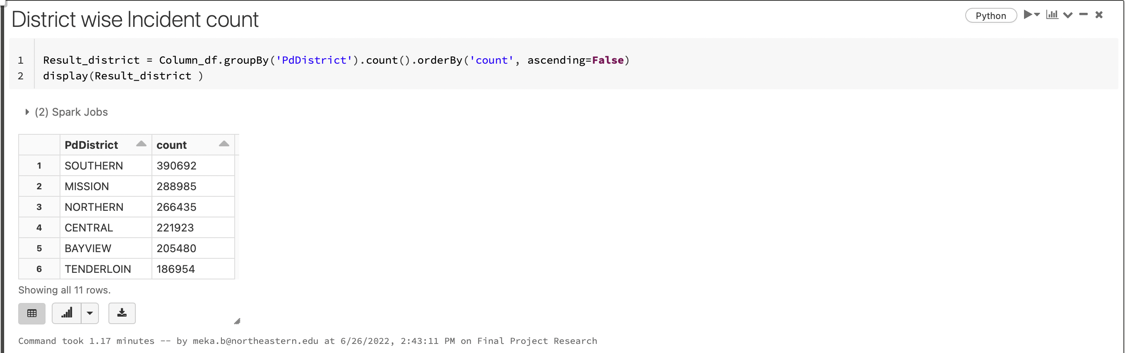

**Visualization showing count of Incident of all districts using display ()** function to plot the graph District vs Count. The district with decreasing order of incidents count are Southern, Mission, Northern, Central, Bayview, tenderloin, Ingleside, Taraval, Park and Richmond respectively.

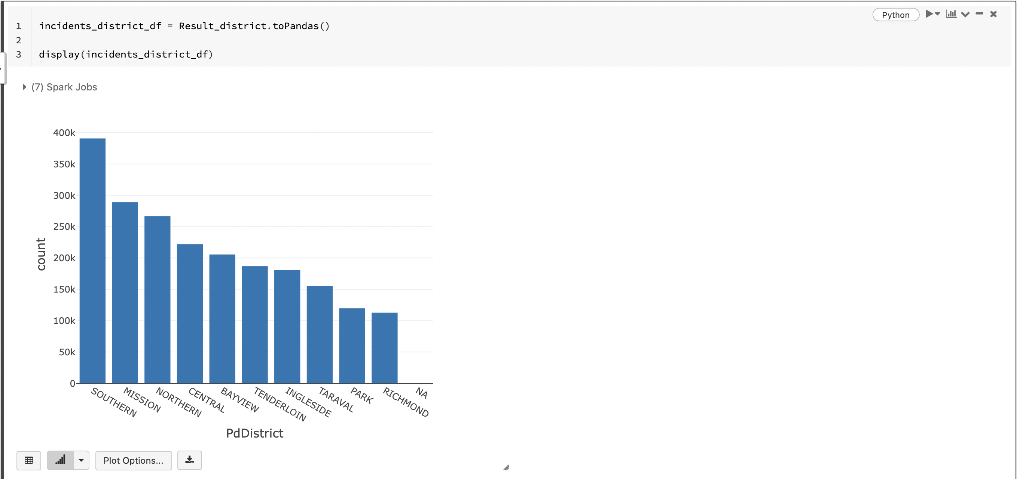

Graph of Number of Crimes by District using the function barplot () imported from the package seaborn. The Highest count of incidents is in Southern and lowest count of incident is Richmond after the row value NA.

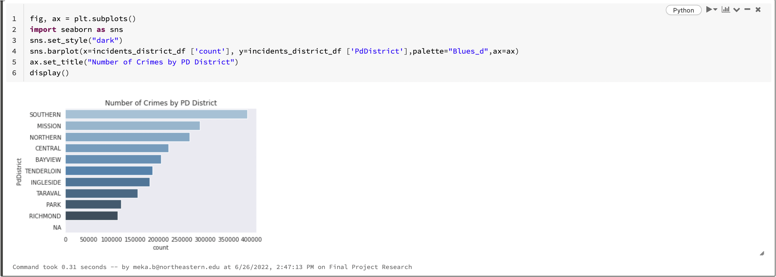

**Total Crime Count of latest 5 years of data (2014-2018)**

In the step of analysis, we **modified the attribute name x to latitude, y to longitude** and **extracted month and year attribute for incident date to retrieve the data from 2014 to 2018 incidents** for our latest updates to predict future the business solutions.

The output in the image below is displaying the top 3 rows of the data frame modified_df in which we modified and extracted attributes

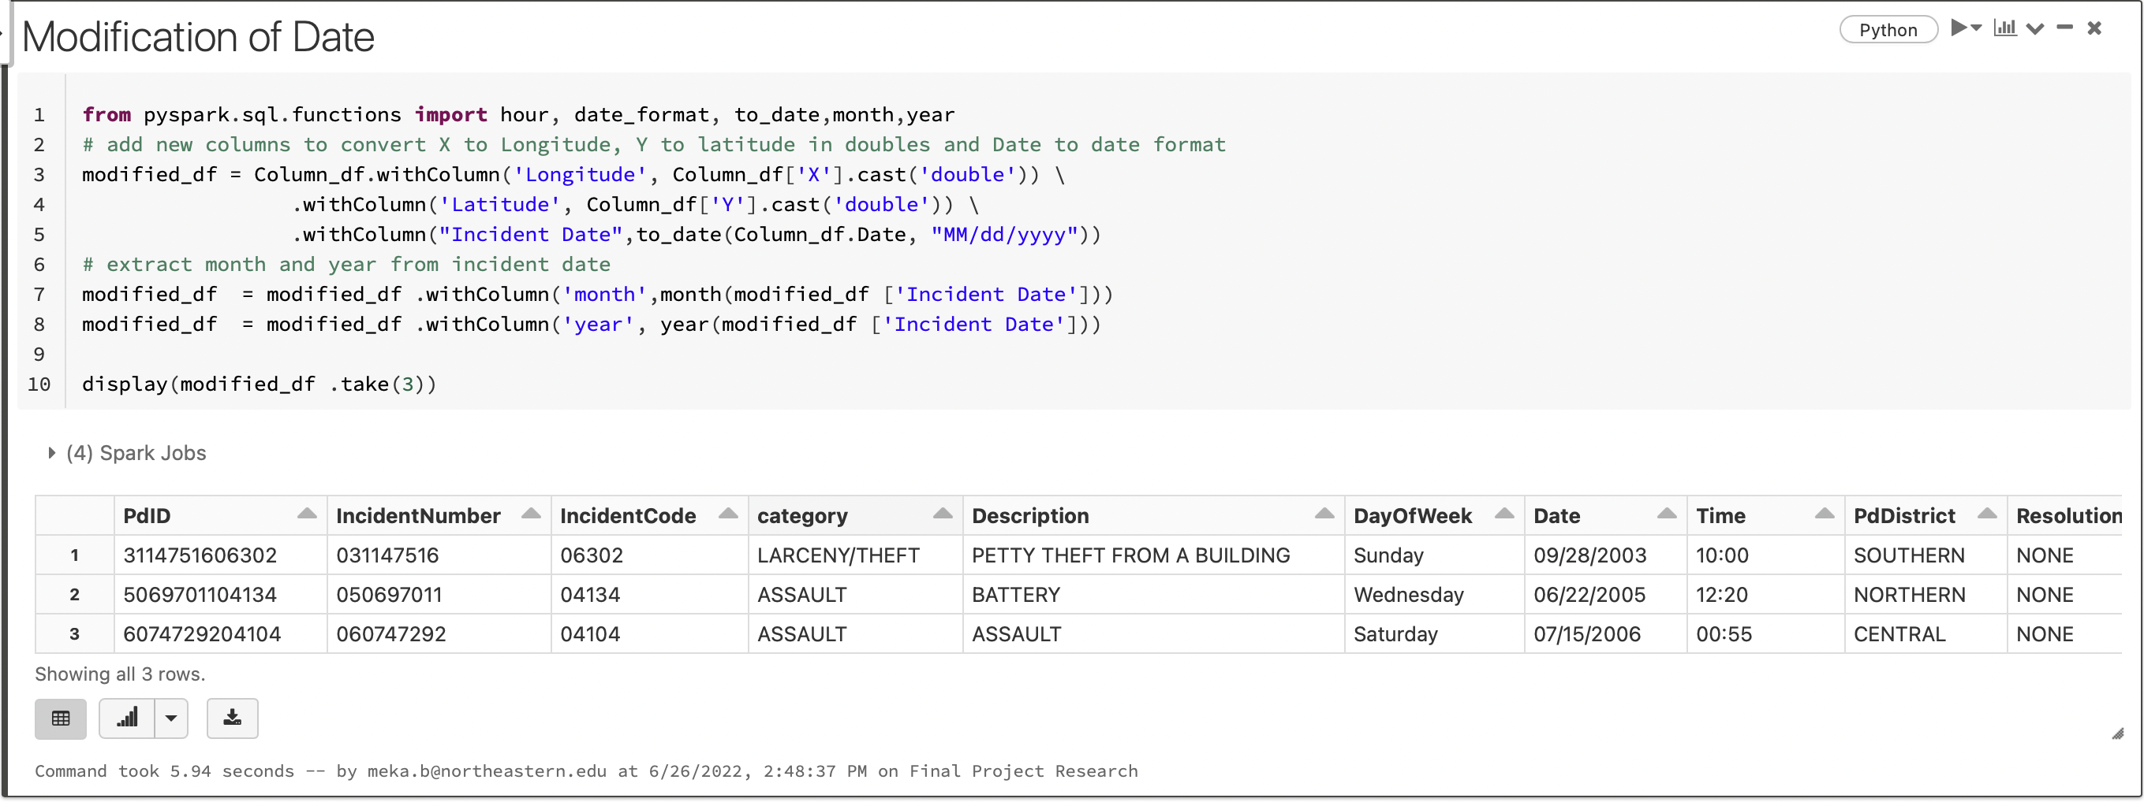

We filtered the data by choosing latest 5 years (2014, 2015, 2016, 2017, 2018) to separate the latest dataset from the previous years to find out the count of incidents monthly and yearly.

The output below is displaying the top 3 rows of years 2014-2018 of the attributes used for the analysis.

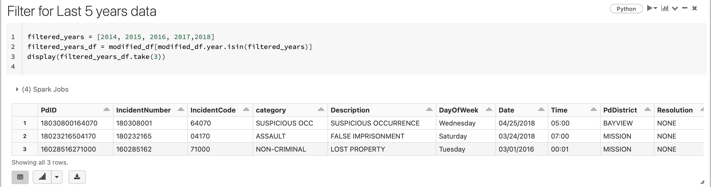

Using the display function, I plotted a graph count and month 1 to 12 to observe the count of incidents yearly. I used the query and data frame I created in previous step with data of 2014,2015,2016,2017 and 2018 and organized the data using group by and order by (Month, Year).

In the output below we can see that in year 2018, from 6th month to 12th month in that year the count of incidents decreased from10k to almost 0 where the range of crime incidents from 2014 to 2017 is between 11k to 14k approximately.

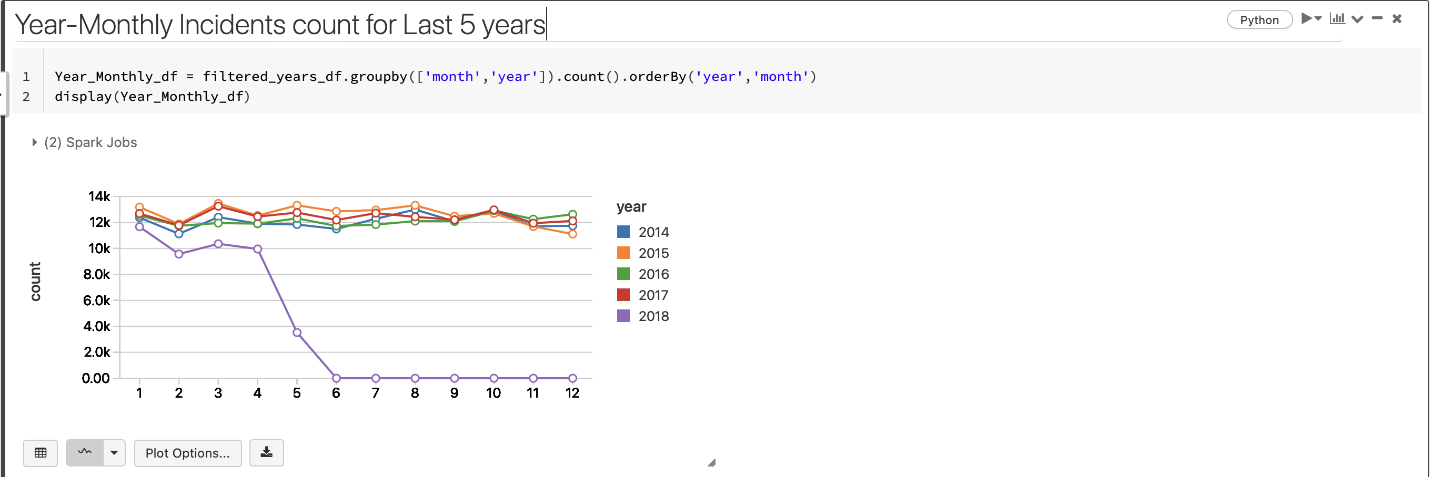

**Total number of incidents in every district from 2004 to 2018**

Firstly, to do this analysis we need to extract hour and create a new attribute. To do so, we need to import to_timestamp function from package pyspark.sql.functions. In the image below you can see that We created a new data frame to extract and create the attribute hour and to find out if its created, We used the display () function to display the first 3 rows of the modified data frame created.

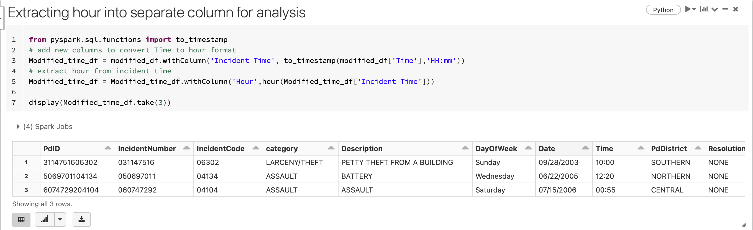

To plot the graph, we imported the function called function from pyspark.sql and named it F and assigned a simple query using the Modified data frame created in the last step using group by and order by function to organize them according to decreasing order of year and count.

From the graph we can make observations that Richmond has the lowest incident count from 2004 to 2018 which is 119698. And second lowest crime in Park 119698.

We can clearly observe from graph that all the districts show decline in from the year 2017 and the highest decline is in the Southern district which had highest count of incidents from 2004 to 2018.

In the image below we can observe from the output table, attributes name of district and count of incidents from each district is shown in a decreasing order.

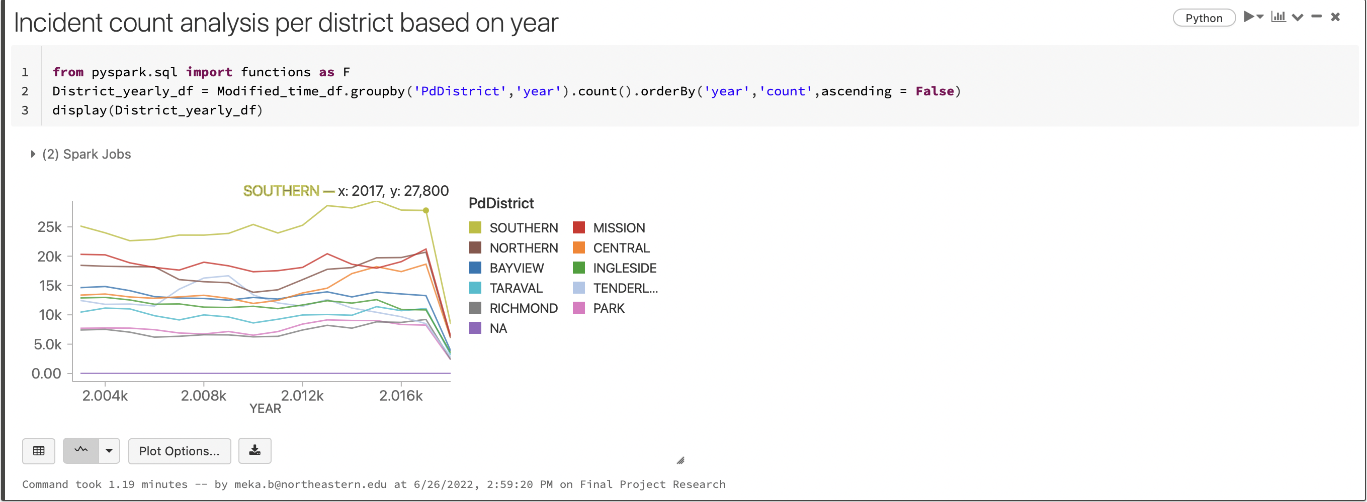

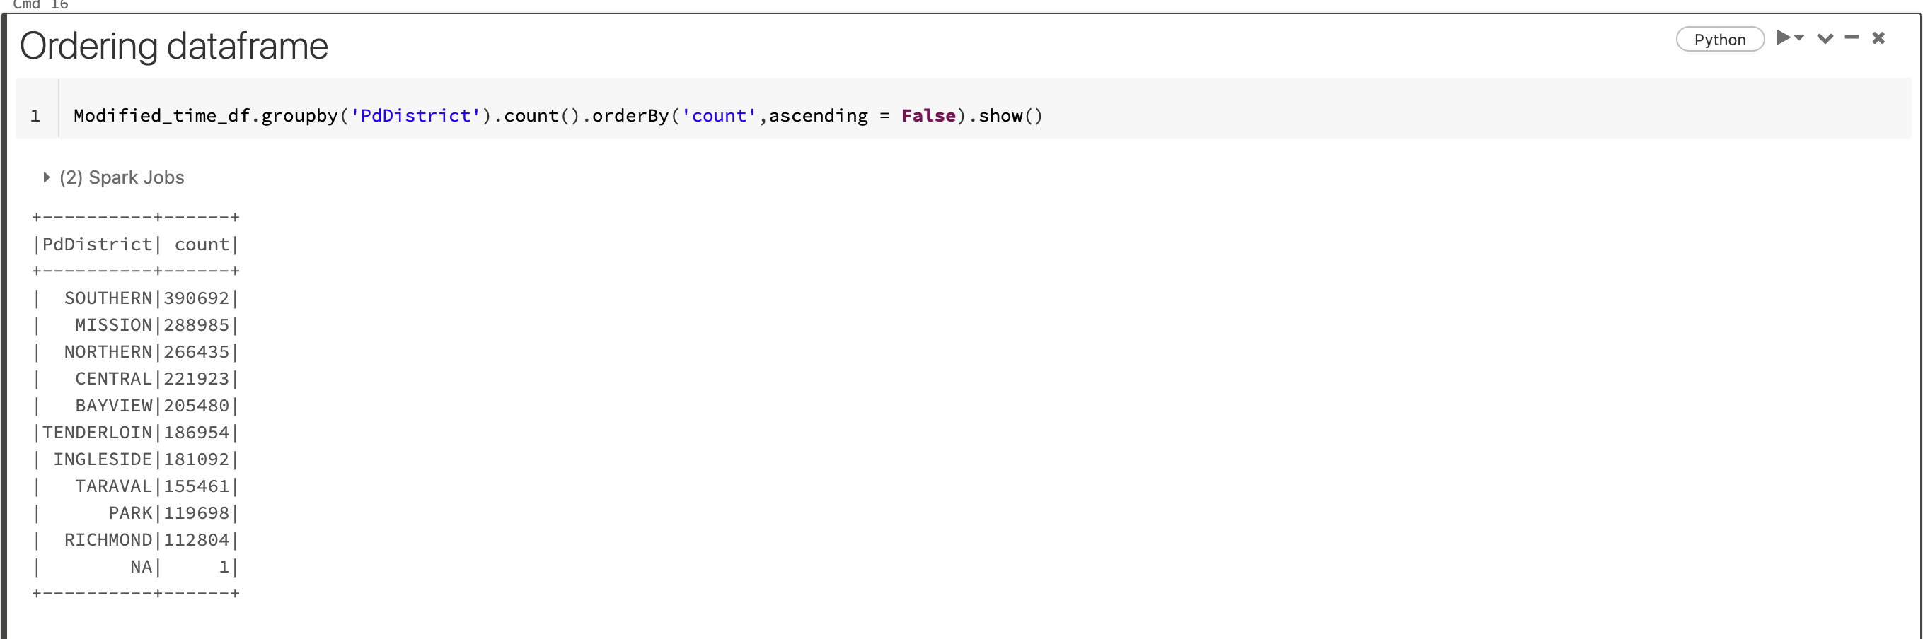

**Crimes per every hour of day from Districts with Top 5 Incident Count**

In the previous problem we found out the incident count by district in a decreasing order. For this problem we are going to take only 5 districts with highest incident count.

In the image below I executed a query and stored the 5 districts Southern, Mission, Northern, Central and Bayview in object ‘Top5_Districts’ which is an array.

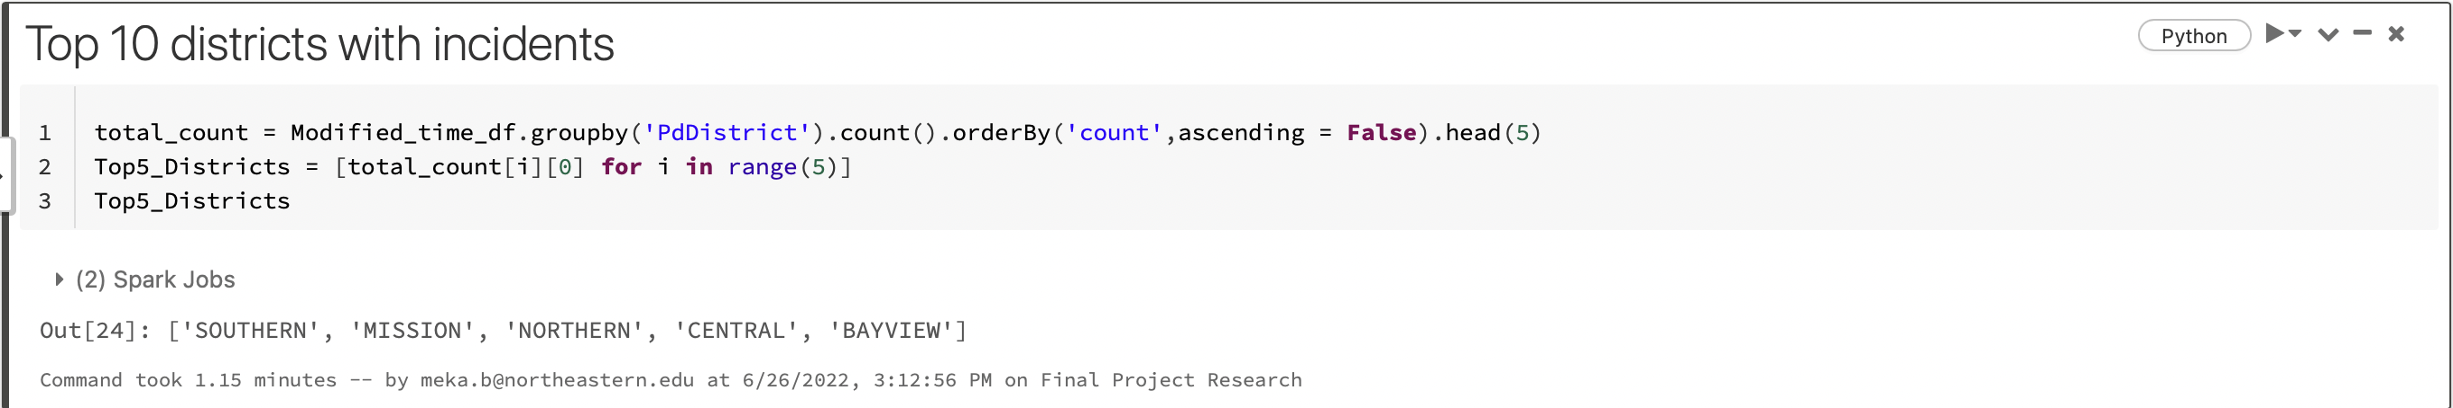

We plotted the graph between hour and count of the incidents showing the crime count of Districts Southern, Mission, Northern, Central and Bayview all indicated with different colors.

We can observe from the graph that,

* the crime counts in districts Southern is highest in 18th hour of the day and second highest crime count is at 12thth hour.
* The lowest crime counts hours for all districts is between 3rd and 6th hour.
* The top three hours of highest crime rate in Northern is 18th hour, 12th hour and 0th hour respectively.
* The top three hours of highest crime rate in Mission is 0th hour, 18th hour and 12th hour respectively.
* The top three hours of highest crime rate in Central is 12th hour, 0th hour and 18th hour respectively.
* The top three hours of highest crime rate in Bayview is 12th hour, 18th hour and 0th hour respectively.

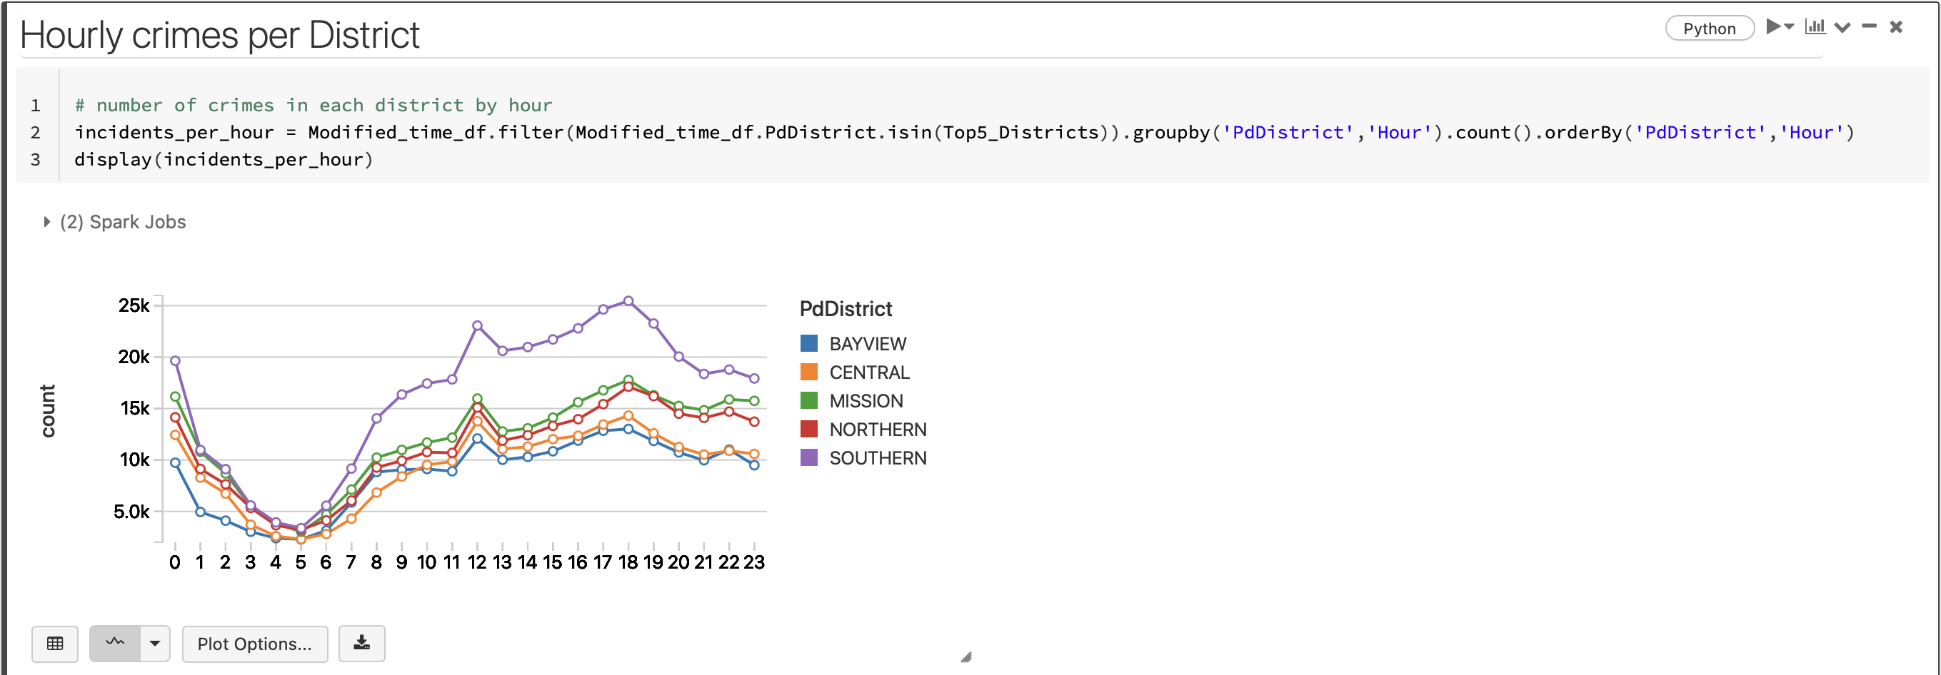

**Top 5 types of incidents from the 4 districts Northern, Mission, Central and Bayview**

Firstly we imported Window function from pyspark.sql.window to separate all the districts and incident count for each district and also imported rank() and Col() function from pyspark.sql.functions to rank the incidents with respect to their percentage of each incident.

In the output below we can observe top that,

* In Northern the highest percentage of category of incident is 47% which is Larceny/Theft followed by 18% Other offense cases, 15% of non-Criminal cases,11% of Assault cases and 9% of theft cases.
* In Mission the highest percentage of category of incident is Larcency/theft with 29% followed by 27% Other Offense cases, 18% of non-criminal cases, 15% of Assault cases, 11% of Drug/Narcotic cases.
* In Central the highest incident category is Larceny/Theft which is 48% followed by 19% Non-Criminal Cases, 15% Other Offenses cases, 10% Assault cases, 8% Vandalism cases.
* In Bayview there are 33% of Other Offenses cases, 23% of Larceny/Theft cases,17% of assault cases, 14% of Vehicle theft and 13% of Non-Criminal Cases.
* We can observe that Larceny/Theft cases are in top incident category in all the four districts.
* Drug/Narcotic category fall in top 5 incident category only in one district which is Mission with 11% of total cases.
* Vandalism category fall in top 5 incident category only in one district which is Central district with 8% of cases.

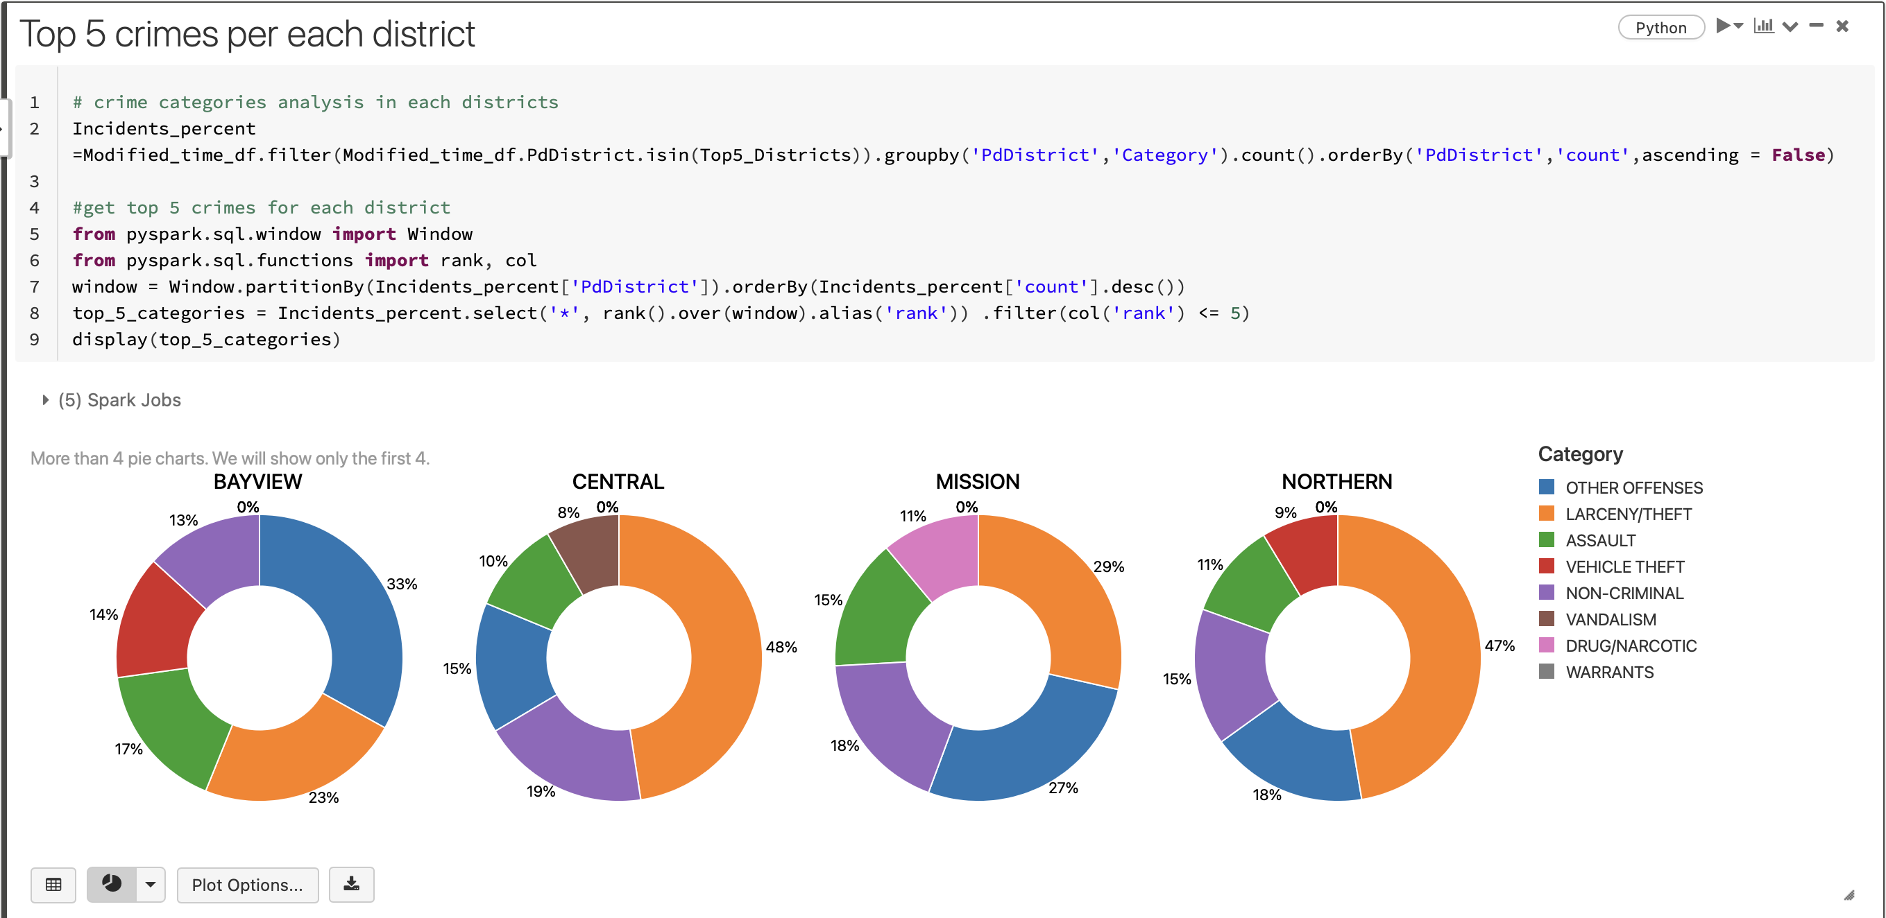

I plotted another bar graph changing the plotting options and using display () function displaying the array Top 5 Categories as in the above image we could only see pie chart visualizations of 4 districts.

In this graph we can observe that Southern district which has highest incident count has more that 100K Larceny/Theft cases, nearly 45k Other Offenses and Non-Criminal cases, nearly 25K Assault cases and approximately 21k Warrants.

The highest number of incident category in 4 out of 5 districts is Larceny/Theft (except Bayview).

The highest number of incident category is Other Offenses in Bayview.

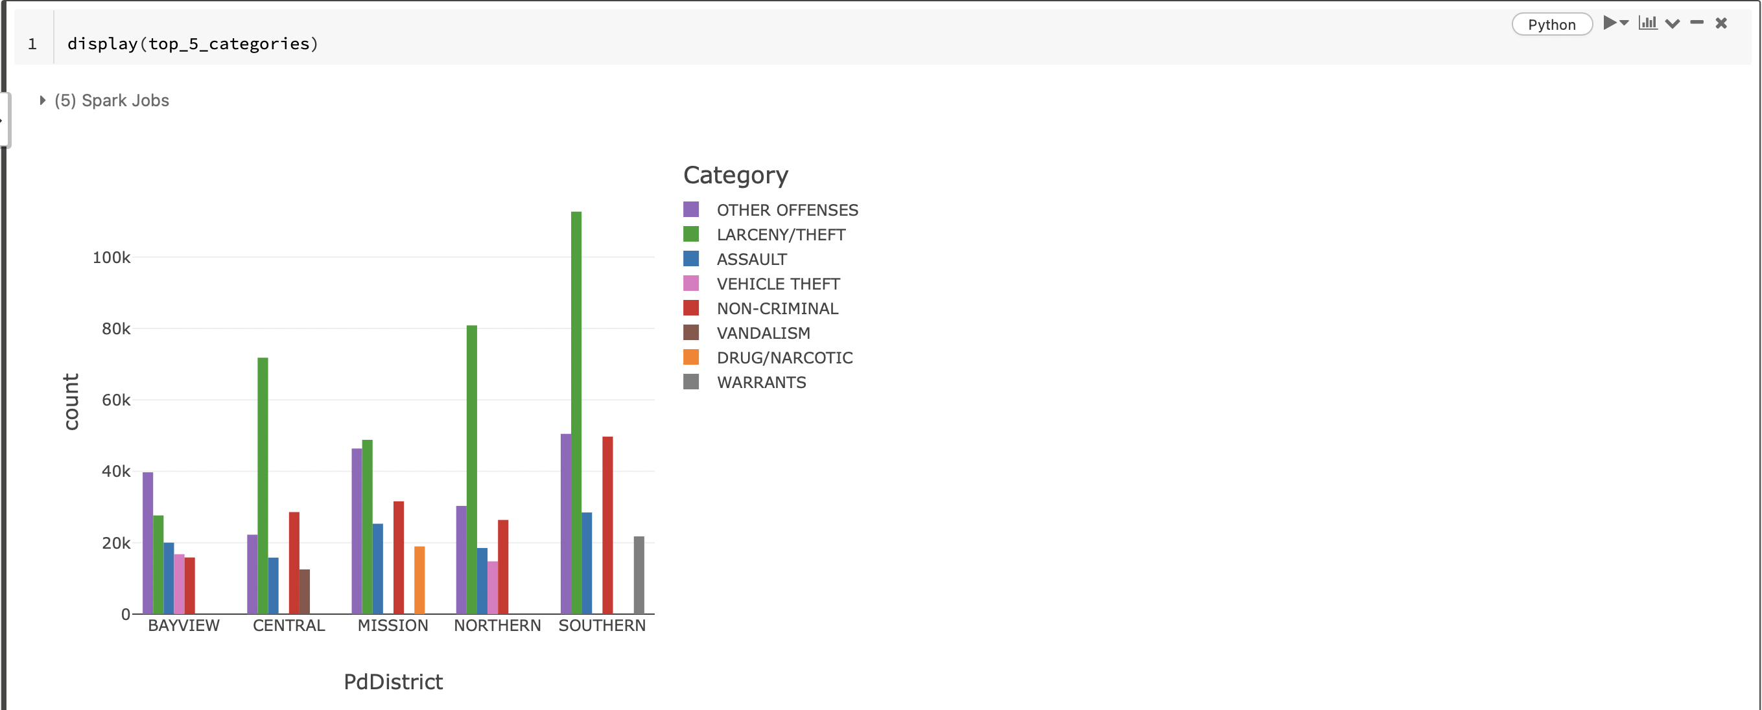

**Conclusion**

* Larceny/theft with count 477975, Other Offenses category with count 301874, non-Criminal with count 236928, Assault cases are 167042, Vehicle theft cases are 126228 Drug/Narcotic are 117821, Vandalism approximately 115k, Burglary 90k and Suspicious OCC 80k.
* The district with decreasing order of incidents count is Southern, Mission, Northern, Central, Bayview, tenderloin, Ingleside, Taraval, Park and Richmond respectively.
* In year 2018, from 6th month to 12th month in that year the count of incidents decreased from10k to almost 0 where the range of crime incidents from 2014 to 2017 is between 11k to 14k approximately.
* Richmond has the lowest incident count from 2004 to 2018 which is 119698. And second lowest crime in Park 119698.
* All the districts show decline in Total incident count from the year 2017 and the highest decline is in the Southern district which has highest count of incidents from 2004 to 2018.
* The top three hours of highest crime rate in Northern is 18th hour, 12th hour and 0th hour respectively.
* The top three hours of highest crime rate in Mission is 0th hour, 18th hour and 12th hour respectively.
* The top three hours of highest crime rate in Central is 12th hour, 0th hour and 18th hour respectively.
* The top three hours of highest crime rate in Bayview is 12th hour, 18th hour and 0th hour respectively.
* Drug/Narcotic category fall in top 5 incident category only in one district which is Mission with 11% of total cases.
* Vandalism category fall in top 5 incident category only in one district which is Central district with 8% of cases.
* The highest number of incident category in 4 out of 5 districts is Larceny/Theft (except Bayview).
* The highest number of incident category is Other Offenses in Bayview.

**Appendix**

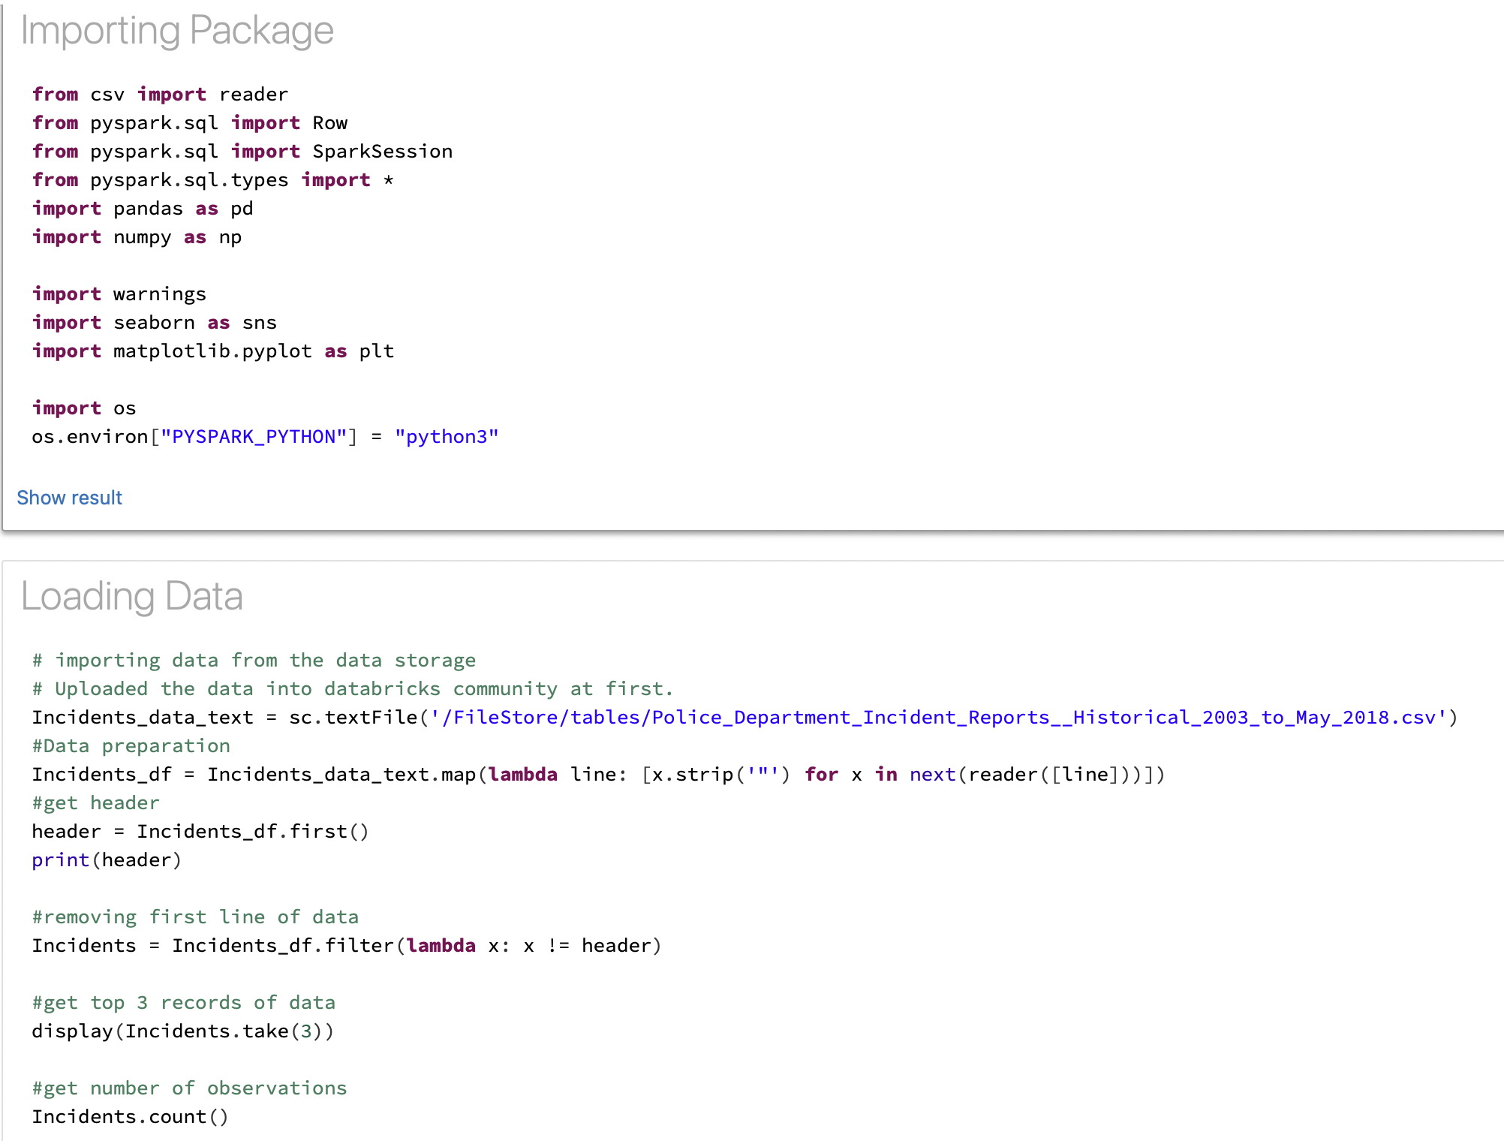

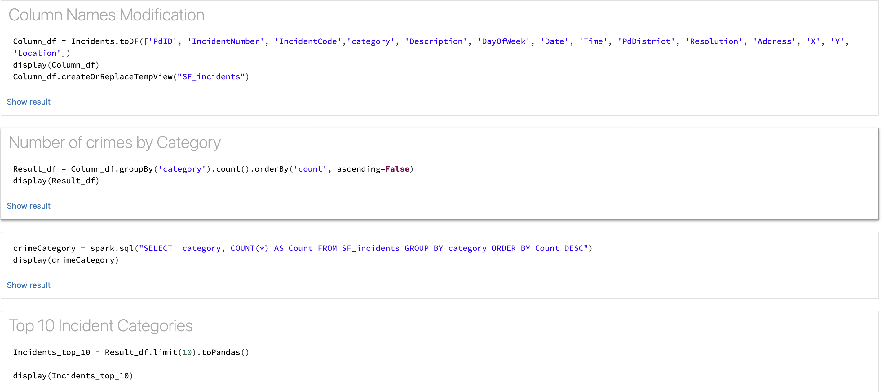

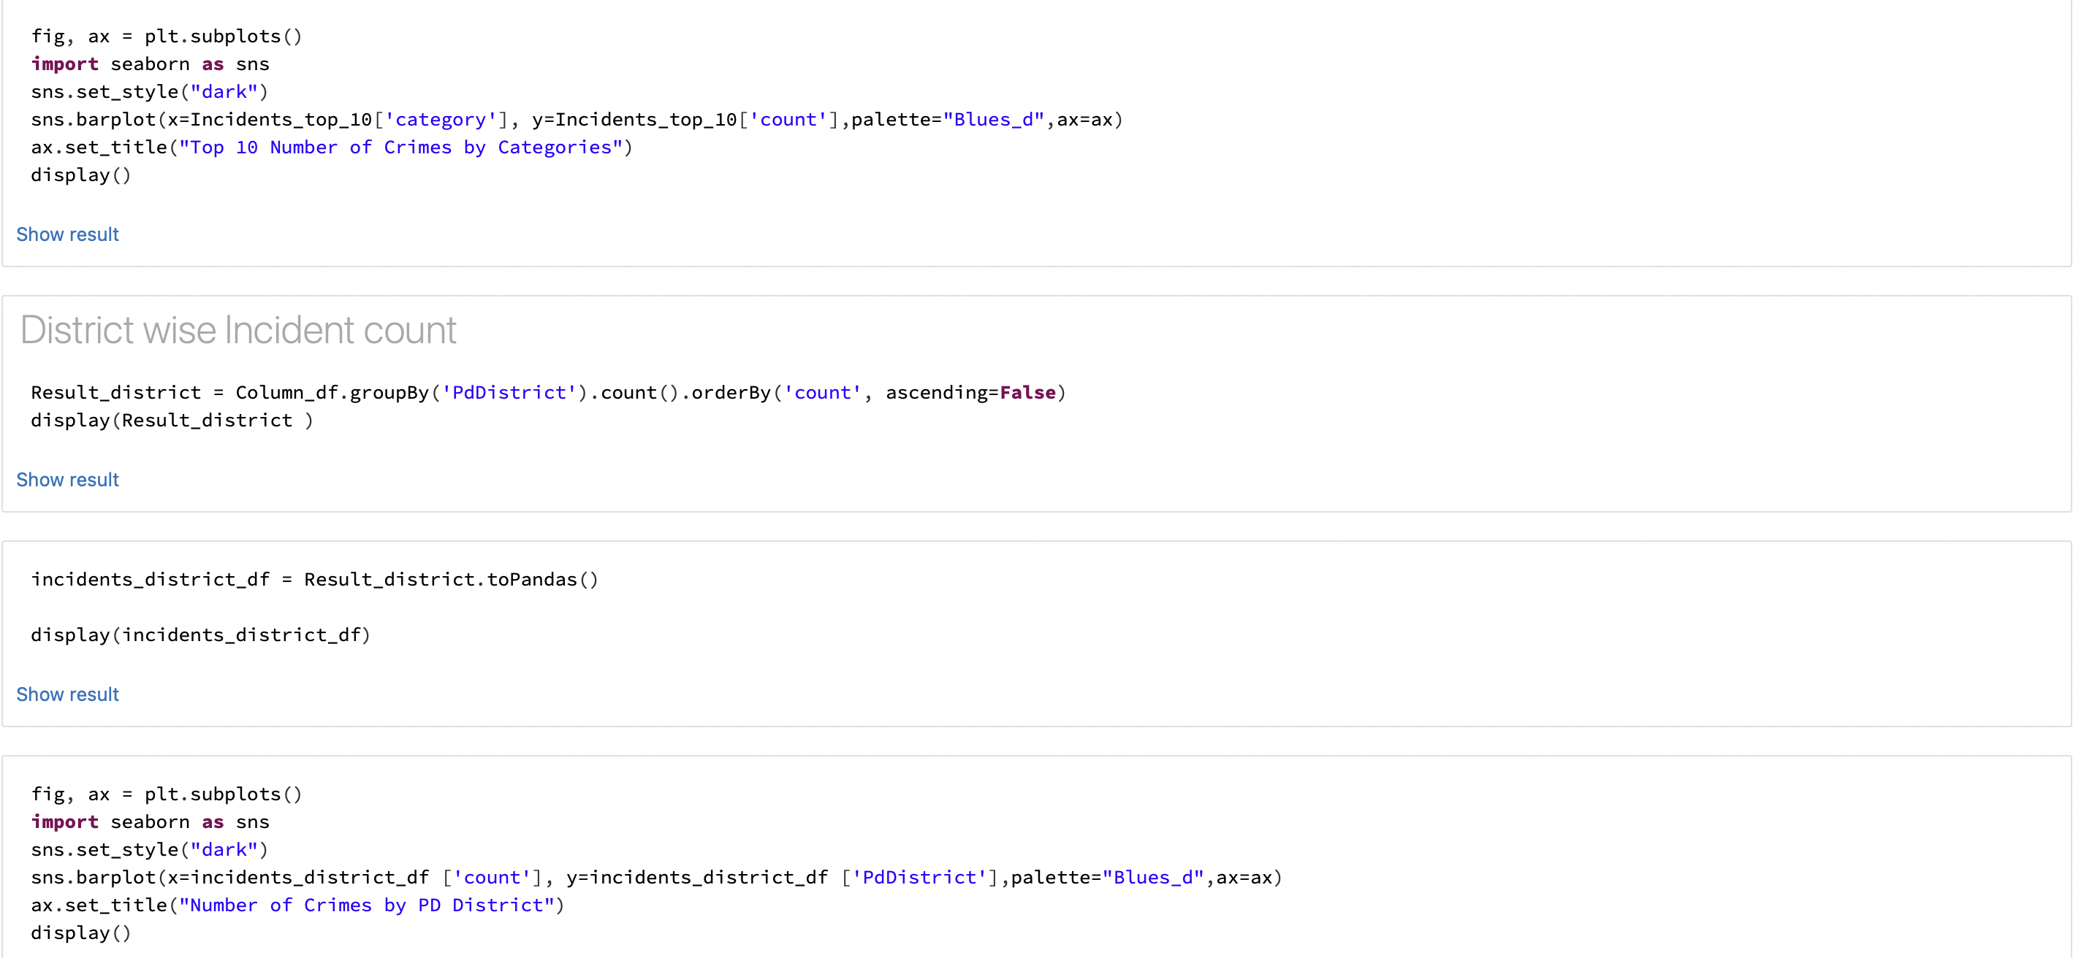

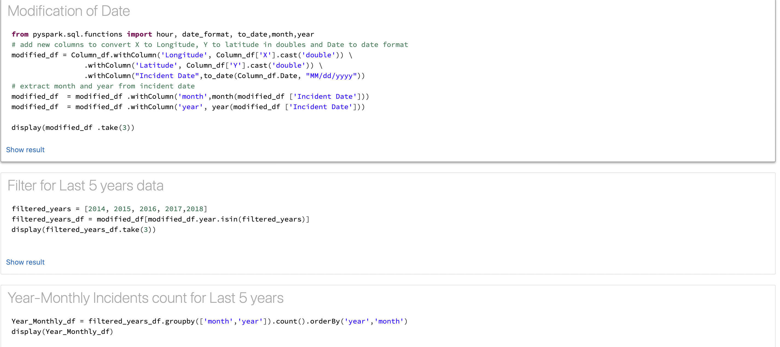

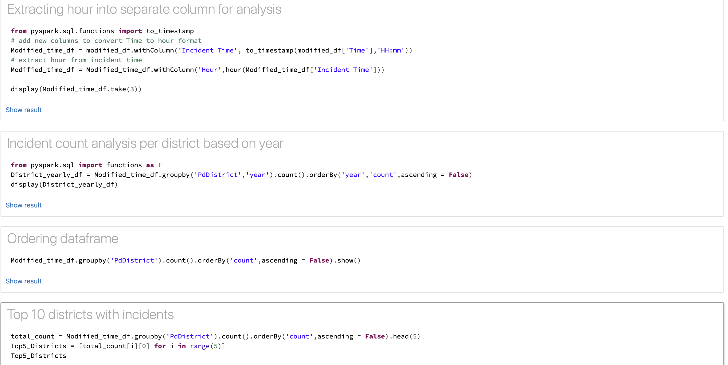

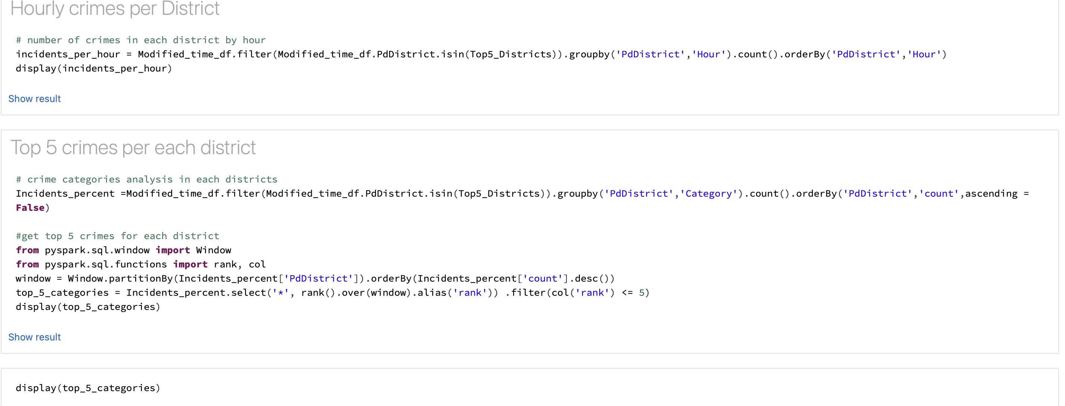

**References**

* Data SF, Open Data, Police Department Incident Reports: Historical 2003 to May 2018, <https://data.sfgov.org/Public-Safety/Police-Department-Incident-Reports-Historical-2003/tmnf-yvry/data>
* Databricks Community Edition, Python For Databricks / PySpark, September 30, 2021 <https://www.youtube.com/watch?v=1_JGvvbtUQU>